NGO VOLUNTEER MANAGEMENT SYSTEM — PROJECT REPORT
- Project Title-NGO VOLUNTEER MANAGEMENT SYSTEM

- Student Details
Enrollment Number: IU2641231914
● Project Code: CPP914
● Project Name: NGO VOLUNTEER MANAGEMENT SYSTEM

Problem Statement
Non-Governmental Organizations (NGOs) rely heavily on volunteer contributions and community-driven events to carry out social impact initiatives. However, conventional coordination workflows relying on manual logs, ad-hoc messaging channels, and static spreadsheets face severe operational bottlenecks. Manual scheduling leads to frequent volunteer double-booking, lack of validation against volunteer weekly hour limits, inaccurate task allocation, and missing audit trails for event completions.

Furthermore, retaining volunteer profiles, assigned project history, and engagement metrics persistently across operational sessions without database corruption presents a critical challenge.

This system provides a robust, object-oriented console application in C++ engineered to track NGO volunteers, schedule social drives and events, assign volunteers based on capacity and skill match, log service assignments, and guarantee end-to-end data persistence using structured file storage.

Objectives

- Build a modular C++ console application adhering to strict Object-Oriented Programming (OOP)
paradigms.
- Implement standard base-derived class inheritance along with pure virtual runtime polymorphism.
- Utilize explicit dynamic memory allocation (new[] and delete[] ) for dynamic resource handling.
- Ensure persistent file storage (. txt files with pipe-delimited formatting) across application restarts.
- Provide interactive console menu operations: Add, Display, Search, Update, Delete, Main Transaction (Assign/Complete Task), and Report Generation.
- Implement input validation and exception handling to prevent application runtime failures.

Features

- Add Record: Registers new Event/Drive instances (ID, Title, Location, Required Volunteers) and Volunteer instances (ID, Name, Email, Skill/Role, Max Weekly Hours).
- Display Records: Renders clean, tabulated summaries of all registered volunteers and scheduled events using polymorphic display routines.
- Search Record: Performs lookups for individual records matching user-supplied Volunteer or Event IDs.
- Update Record: Allows editing existing event attributes (title, location, requirements) or contact details and skill sets for volunteers.
- Delete Record: Safely removes specific volunteer or event records from internal dynamic memory arrays.
- Main Transaction/Process (Assign/Complete Event Assignment): Handles core NGO workflow logic, verifying volunteer limits, checking event capacity, and logging Assignment records.
- Report: Displays aggregate organization metrics (total volunteers, active events, completed drives) and audit trails.
- Save/Load: Triggers manual dynamic array serialization/deserialization to file storage.
- Exit: Performs auto-saving of all dynamic data state to text storage files before freeing memory and terminating.

Classes and Responsibilities
1 . Person (Abstract Base Class)
Responsibility: Serves as the abstract foundation for all individual human entities in the organization.
Data Members: #id (int), #name (string), #email (string).
Key Functions: Person(), virtual ~Person(), getId(), virtual void display() const
= 0.
2. Volunteer (Derived from Person)
Responsibility: Manages volunteer-specific engagement constraints, assigned hours, and operational status.
Data Members: - skill, - maxHoursAllowed, - hoursLogged, - activeAssignments.
Key Functions: canTakeAssignment(), logHours(), incrementAssignments(), display() const override.

4. Assignment Class (Transaction Class)
Responsibility: Encapsulates assignment activity records linking volunteers to events.
Data Members: - assignmentID, - volunteerID, - eventID, - assignmentDate, - status.
Key Functions: markCompleted(), displayAssignment().
5. FileManager Class
Responsibility: Handles reading/writing entity records between memory arrays and external . txt
files.
Key Functions: saveVolunteers(), loadVolunteers(), saveEvents(), loadEvents().
6. NGOManager (System Coordinator)
Responsibility: Contains full business logic, manages dynamic heap arrays, and coordinates entities.
Key Functions: addRecord(), processMainTransaction(), generateReport(), saveData().

OOP Concepts Used

Encapsulation
Data members are protected using private or protected visibility modifiers. Direct field mutation is prevented, and access is controlled via explicit getters and setters.
C++ : Encapsulation Example

class Event { private: int eventID; int requiredVolunteers; int assignedCount; public: bool isFull( ) const { return assignedCount >= requiredVolunteers; } void assignVolunteer( ) { if ( ! isFull( ) ) assignedCount++; } };

Inheritance & Polymorphism
The Volunteer class publicly inherits from the abstract Person base class. The Person class defines a pure virtual display() method, which the coordinator dynamically dispatches at runtime via Person* pointers.
C++ : Inheritance Example

Dynamic Memory Management
Internal collections are managed via dynamically allocated arrays on the free store (heap) using new[]
during initialization, with clean deallocation via delete[] within the coordinator class destructor.
C++ : Dynamic Allocation

// Allocation in Constructor volunteers = new Volunteer[ capacity] ; events = new
Event[ capacity] ; // Deallocation in Destructor delete[] volunteers; delete[] events;

File Handling

Data persistence is achieved by parsing raw record lines from text files inside the Data/ directory using pipe-separated syntax:

- Data/volunteers. txt: Stores ID, Name, Email, Skill, Max Hours, and Logged Hours.
- Data/events. txt: Stores Event ID, Title, Location, Required Count, Assigned Count.
- Data/assignments. txt: Stores Assignment details and completion status.

std: : ifstream and std: : ofstream combined with std: : stringstream serialize and deserialize active memory objects, ensuring application state is restored seamlessly across restarts.

System Architecture (UML Highlights)

The system is coordinated by the NGOManager which aggregates arrays of entities and handles file operations.
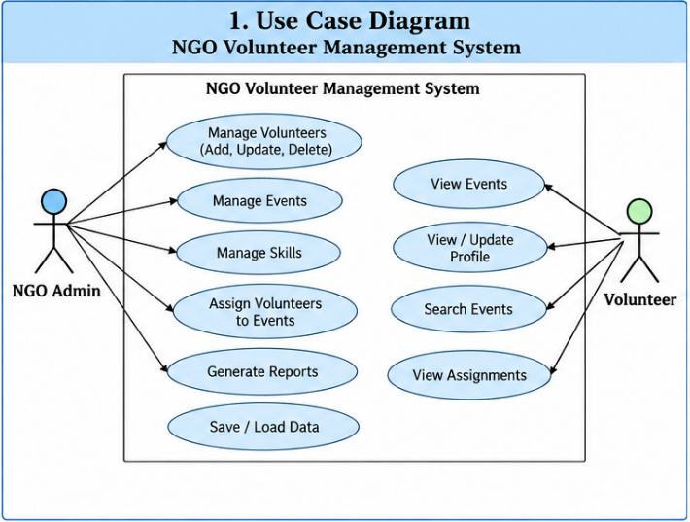

Figure 1: Use Case Diagram

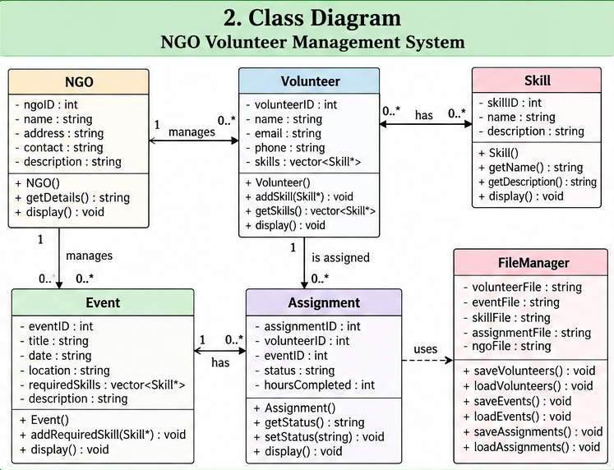

Figure 2: Class Diagram

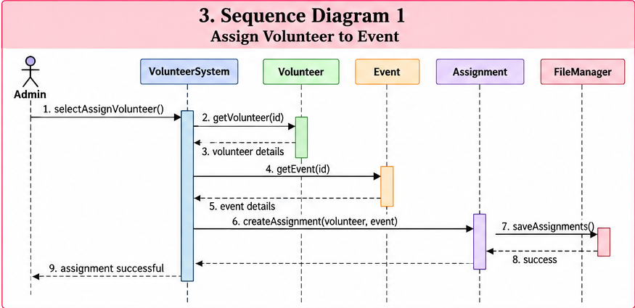

Figure 3: Sequence Diagram 1 – Assign volunteer to event

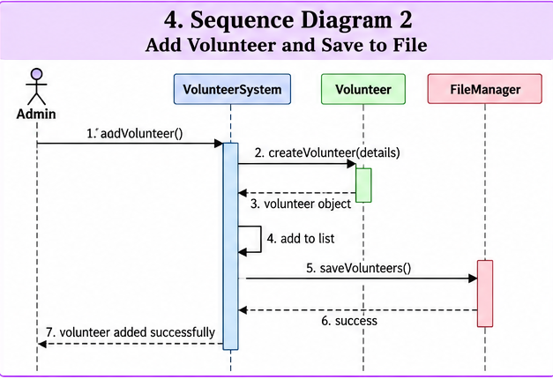

Figure 3: Sequence Diagram 2 – Process Blood Request

Program Workflow

- Startup: main() instantiates the NGOManager coordinator object.
- Data Loading: The constructor allocates heap memory and invokes loadData(), prompting
FileManager to populate arrays from disk.
- Menu Loop: User interacts with a 9-option interactive console menu.
- Routing: Choices trigger routines like processMainTransaction().
- Termination: Option 9 flushes memory states to disk storage via saveData() before calling
delete[] and exiting.

Console Interface (Screenshots)

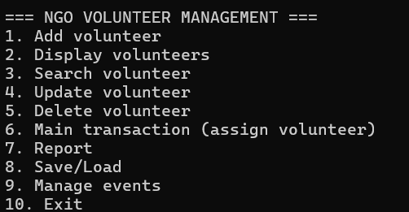

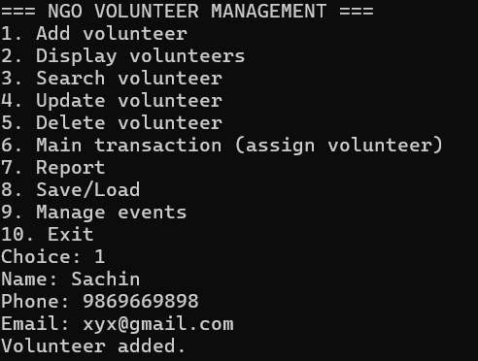

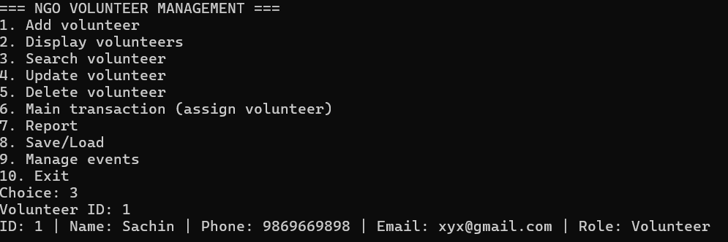
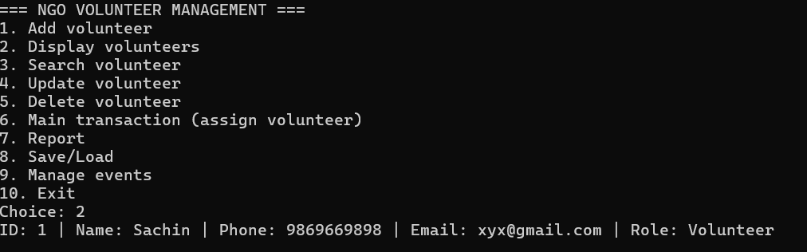
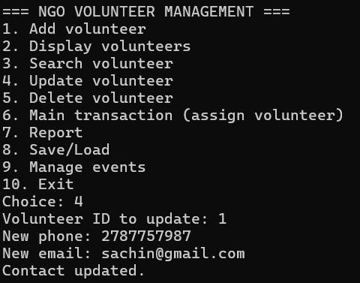

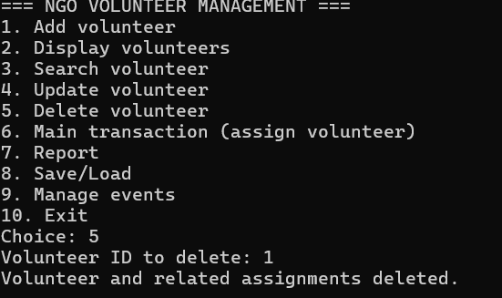

Testing

Test Case | Scenario / Input | Expected Output | Result
TC_01 | Add Volunteer ID: 501 , Name: "Aarav", MaxHours: 1 5 | Volunteer recorded and added to dynamic array | PASS
TC_02 | Add Event ID: 201 , Title: "Food Distribution", Capacity: 5 | Event recorded and added to dynamic array | PASS
TC_03 | Assign Volunteer 501 to available Event 201 | Assignment record created; Event slots updated | PASS
TC_04 | Assign Volunteer 501 when current hours equal limits | Display "Error: Volunteer has reached maximum hours limit!" | PASS
TC_05 | Assign to Full Event (slots fully booked) | Display "Error: Event slots are fully booked!" | PASS
TC_06 | Save data and relaunch application | Previous session volunteer and event data retained from .txt storage | PASS

Challenges and Solutions

- Relative Path File Open Failures: Executing the compiled binary from varying command-line directories caused the file manager to search non-existent directory trees. This was resolved by implementing a path verification routine (resolvePath()) that checks multiple relative levels before failing.

- Memory Leaks: Allocating dynamic memory for lists without explicit cleanup sequences caused heap allocations to linger. Strict RAII-compliant destructor routines were implemented across coordinator classes invoking delete[] on all heap arrays upon termination.

Conclusion

The NGO Volunteer Management System project was successfully designed and implemented in modular C++, satisfying all software engineering and architectural requirements. The application demonstrates core object-oriented principles, including abstract base classes, inheritance hierarchies, runtime polymorphism, structured file I/O persistence, dynamic heap array allocation, and defensive input validation.

